MATH 115 QUIZ 1 Instructor: I. Izmirli

NAME: _______________________________
I have completed this assignment myself, working independently and not consulting anyone except the instructor.

INSTRUCTIONS
- The quiz is worth 100 points. There are 10 problems. This quiz is open book and open notes. This means that you may refer to your textbook, notes, and online classroom materials, but you must work independently and may not consult anyone (and confirm this with your submission). You may take as much time as you wish, provided you turn in your quiz no later than Sunday, July 2.
- Show work/explanation where indicated. Answers without any work may earn little, if any, credit. You may type or write your work in your copy of the quiz, or if you prefer, create a document containing your work. Scanned work is acceptable also. In your document, be sure to include your name and the assertion of independence of work.
- General quiz tips and instructions for submitting work are posted in the Quizzes module.
- If you have any questions, please contact me by e-mail.

1. (4 pts) Consider the interval [0, ∞). For each numerical value below, is it in the interval or not?
(Just answer Yes or No)

$\frac{0}{5}$ _______ – 3 ² _______ | –8.5 | _______ 7 ^{–3} _______
(Yes or No) (Yes or No) (Yes or No) (Yes or No)

2. (4 pts) Given $f\left(x\right)=\sqrt{x-2}$ and $g\left(x\right)=x-7$, which of the following is the domain of the quotient function? (No work required) 2._______
A. $\left(2, ∞\right)$
B. $\left[\left.2, ∞\right)\right.$
C. $\left(-∞, 7\right)∪\left(7, ∞\right)$
D. $\left[\left.2, 7\right)\right. ∪ \left(7, ∞\right)$

3. (8 pts) Consider the points (–5, 2) and (–1, 10).
(a) State the midpoint of the line segment with the given endpoints. (No work required)

(b) If the point you found in (a) is the center of a circle, and the other two points are points on the circle, find the length of the radius of the circle. (That is, find the distance between the center point and a point on the circle.) Find the exact answer and simplify as much as possible. Show work.

4. (12 pts) Analyze each of the four graphs as requested below.(no explanation required.)

(A)  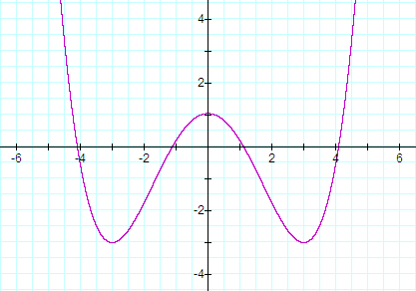  Is the graph symmetric with respect to the  x-axis? ____ y-axis? ____ origin? ____  (State Y for Yes or N for No in each blank.)  Does the graph represent a function?  Yes or No: _____  If the graph does represent a function, is the function  even, odd, or neither even nor odd?  (choose one, if applicable). | (B)  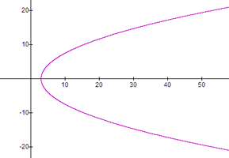  Is the graph symmetric with respect to the  x-axis? ____ y-axis? ____ origin? ____  (State Y for Yes or N for No in each blank.)  Does the graph represent a function?  Yes or No: _____  If the graph does represent a function, is the function  even, odd, or neither even nor odd?  (choose one, if applicable).
(C)  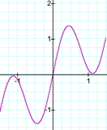  Is the graph symmetric with respect to the  x-axis? ____ y-axis? ____ origin? ____  (State Y for Yes or N for No in each blank.)  Does the graph represent a function?  Yes or No: _____  If the graph does represent a function, is the function  even, odd, or neither even nor odd?  (choose one, if applicable). | (D)  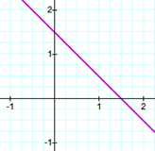  Is the graph symmetric with respect to the  x-axis? ____ y-axis? ____ origin? ____  (State Y for Yes or N for No in each blank.)  Does the graph represent a function?  Yes or No: _____  If the graph does represent a function, is the function  even, odd, or neither even nor odd?  (choose one, if applicable).

5. (4 pts) For income x (in dollars), a particular state's income tax T (in dollars) is given by

$$T\left(x\right)=\left\{\begin{matrix}0.028x & if 0 ≤x≤4,000 \\ 112+0.035(x-4,000) & if 4,000<x≤24,000 \\ 812+0.050(x-24,000) & if x>24,000\end{matrix}\right.$$

What is the tax on an income of $42,000? Show some work.

6. (16 pts) Consider the following graph of y = f (x). (no explanations required)

(a) State the x-intercept(s).  (b) State the y-intercept(s).  (c) State the domain.  (d) State the range.  (e) State the value of f (3). | 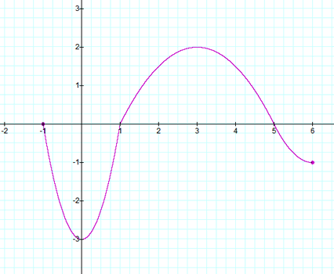

(f) State the interval(s) on which the function is decreasing. That is, for what x-values is the function decreasing?

7. (14 pts) Let y = 8 − 2x².

(a) Create a table of sample points on the graph of the equation (include at least six points). The points should include the x-intercept(s) and the y-intercept(s) of the graph.

x | y | (x, y)

(b) Graph the equation. The graph should include the sample points. (You may use the grid shown below, hand-draw and scan, or you may use the free Desmos graphing calculator described under Course Resource to generate a graph, save as a jpg and attach.)

(c) Is the graph symmetric with respect to the y-axis? _____ (yes or no). If no, state a point on the graph and state the appropriate reflection point which fails to be on the graph, as done in section 1.2 homework in the textbook.

(d) Is the graph symmetric with respect to the origin? _____ (yes or no). If no, state a point on the graph and state the appropriate reflection point which fails to be on the graph, as done in section 1.2 homework in the textbook.

8. (15 pts) Let f (x) = 5x² – 2x + 8 and g(x) = 1 – 3x.

(a) Evaluate the function f for x = a + 3. That is, find f (a + 3) and simplify. Show work.

(b) Evaluate the product function fg for x = –1. That is, find (f g)( –1). Show work.

(c) Find the difference function (f – g)(x) and simplify the results. Show work.

9. (15 pts) See textbook page 82 for a summary of the economic functions (price-demand p, revenue R, cost C, average cost $\overline{C}$, and profit P ) used in this problem. The cost, in dollars, for a company to produce x widgets is given by C(x) = 5000 + 3.00x for x ≥ 0, and the price-demand function, in dollars per widget, is p(x) = 28 − 0.02x for 0 ≤ x ≤ 1400.

(a) Find and interpret C(800).

(b) Find and interpret $\overline{C}$(800). (Note that $\overline{C}$(x) is the average cost function.)

(c) Find and simplify the expression for the revenue function R(x). (work optional)

(d) Find and simplify the expression for the profit function P(x). (work optional) Note that p(x) and P(x) are different functions.

(e) Find and interpret P(800), where P(x) is the profit function in part (d).

10. (8 pts) A graph of y = f (x) follows. No formula for f is given. 10. _______
Which graph (A, B, C, or D) represents the graph of y = f (x + 1) − 1 ?
EXPLAIN YOUR CHOICE. (Grid supplied for scratch work; You are NOT required to submit your own graph)

y = f (x)
2
4
-4
-2
-4
2
4
-2
2
4
-4
-2
-4
2
4
-2

GRAPH A (below) GRAPH B (below)
2
4
-4
-2
-4
2
4
-2
2
4
-4
-2
-4
2
4
-2

GRAPH C (below) GRAPH D (below)
2
4
-4
-2
-4
2
4
-2
2
4
-4
-2
-4
2
4
-2

